**CLASS INSTRUCTOR**

Oundle School was established in 1556 and is one of the country’s leading co-educational boarding and day schools. The School has a turnover in the region of £40m and a staff of approximately 800. The School prides itself on being associated with the best in modern independent school education.

Oundle School is committed to safeguarding and promoting the welfare of children and young people and expects all staff and volunteers to share this commitment. Successful applicants will be required to undergo child protection screening appropriate to the post including checks with past employers and the Disclosure and Barring Service.

About the department

As well as providing new and improved facilities for the School’s pupils, the new Sports Centre facility has been designed to allow increased access to local residents, sports clubs and schools. It includes a large sports hall, 50m swimming pool, 50 station fitness suite, multiple dance studios and café. The new centre also hosts the Schools match-day entertainment for visiting school teams.

After accommodating the educational and social demands of pupils, the School is eager to develop wider access to the Centre and encourages participation by the local community in a range of sports and leisure activities organised and managed by the Centre staff. The Centre is managed by the School’s trading company on a commercial basis. Critical to the success of the Centre is a commercially targeted and client focused staff team. Staff readily accept the responsibility of representing the School and Enterprise company in the local community.

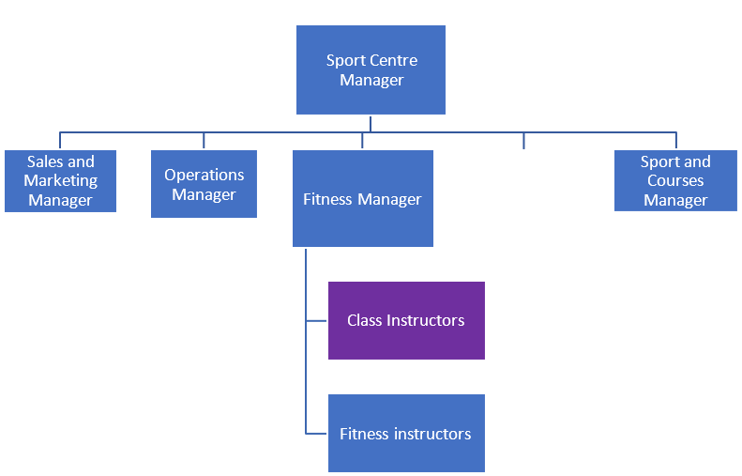

About the role

Working within the Sports Centre team, the role holder will report to the Fitness Manager.

The purpose of the role is to deliver fitness and exercise classes which motivate, educate and encourage adults and children of varying abilities.

Role specification

The main duties and responsibilities of the role are listed below. Please note these are not exhaustive, but highlight the main tasks.

Key Responsibilities

* Plan and deliver various types of fitness and exercise classes and health related training.
* Ensure class needs are met through routines and organisation.
* Work with and motivate class attendees to ensure they are performing exercises and activities correctly and safely.
* Ensure safe provision of all equipment and ensure it is used correctly and to operate within Health & Safety guidelines and undertake risk assessments.
* For the duration of the class to instruct, provide feedback and encouragement to participants
* Welcome all participants in a professional and friendly manner.
* Prepare effectively for classes and share educational information with class participants.
* Log and report any incidents/accidents or any other concerns to a Manager.
* Encourage members to reach their sporting, activity, fitness and wellness goals.
* Keep up to date with fitness and related activity trends and demands.
* Ensure the safeguarding of all children and vulnerable adults.

Duties

* Ensure all classes run to scheduled times and facilities are set up appropriately.
* Ensure the class programmes are safe and appropriate to the needs/abilities of the participants involved and provide supervision and assistance to all participants.
* Recognise your key role in the development of classes.
* Present and conduct yourself in an appropriate manner with courtesy and regard for others.
* Arrange cover for any planned absence and inform the Fitness Manager of the changes in good time.
* Wear suitable clothing for teaching.
* Attend progress and award meetings.
* Liaise with managers to focus on ways to improve the Centre.
* Attend activities completed at the Centre as required to enhance your product knowledge to support customer service and your ability to actively promote the Centre.

Additional Responsibilities

* Represent the School whilst on site in the appropriate manner, including whilst arriving and departing site.
* Wear appointed and appropriate uniform.
* Maintain your qualifications, ensuring they are up to date and relevant.
* Attend team meetings and complete monthly training as required including;
  + Customer care
  + Product knowledge training
  + Emergency action plans
  + Communications
* CPD as appropriate to the role.
* Respect colleagues by meeting common goals and standards;
  + Arriving on time or communicating late attendance
  + Acknowledge, record and report employees and colleague’s concerns.
* Act at all times consistently with Oundle School’s Safeguarding Policy, associated procedures and standards of behaviour and in line with Keeping Children Safe in Education (KCSIE) Part 1 and Annex B.
* Support the School’s Prevent Strategy as outlined in the Prevent Policy in the Staff Handbook, ensuring that visitor and other relevant protocols are observed.
* Demonstrate an appreciation for the importance of diversity, through your actions and behaviours, with the School’s Equality, Diversity and Inclusion Strategy.
* Ensure compliance with the School’s Health and Safety policy and requirements.
* Carry out any other duties commensurate with the post as may be reasonably required by your Line Manager.

*These tasks are not intended to be exhaustive.*

*It is the shared responsibility of the post-holder and line manager to ensure that the job description is kept up to date.*

Equal Opportunities

Oundle School and Laxton Junior School are proud to be equal opportunities employers. We welcome applications from all and value diversity throughout the School community. The School is committed to the elimination of unconscious bias, promoting an ethos of inclusion, respect for others and celebrating diversity in all its forms throughout the School community.

The recruitment process will be conducted in line with our Recruitment and Checks Policy and in such a way as to result in the selection of the most suitable person for the role in terms of relevant experience, abilities and qualifications, as well as to meet the School’s compliance requirements.

The School will make reasonable adjustments to assist in the application and interviewing process of any disability identified by potential applicants, please make contact with the HR team in the first instance c/o [opportunities@oundleschool.org.uk](mailto:opportunities@oundleschool.org.uk) or ring 01832 277193.

Person Specification

The selection of candidates for short-listing will be based on this specification. Candidates should bear this in mind when preparing their application and completing the application form.

|  |  |  |
| --- | --- | --- |
| **Qualifications** | **Essential** | **Desirable** |
| Up to date and valid certification for class being delivered | ✓ |  |
| Exercise to music qualification |  | ✓ |
| Other sports/coaching qualifications |  | ✓ |
| Les Mills/ Exercise to Music Qualifications |  | ✓ |
| **Competencies, Skills & Experience** | **Essential** | **Desirable** |
| Ability to instruct clients of varying ages and abilities | ✓ |  |
| Proven track record of class or course instructing | ✓ |  |
| **Personal qualities** | **Essential** | |
| Confident with the ability to enthuse and motivate clients |  | |
| Flexible with regards to availability |  | |
| Excellent communication skills |  | |

All roles at the School are classed as ‘regulated activity’ as per the Keeping Children Safe in Education guidance, therefore a good understanding of safeguarding procedures is essential.

Employment Information

The role is subject to a six-month probationary period. On completion, you will be expected to participate in the School’s appraisal system.

All members of staff are appointed to the School as a whole and may reasonably be asked to undertake similar or related duties in a department or team other than that to which they were originally appointed, or for any subsidiary company.

The School is committed to safeguarding and promoting the welfare of children and young people, and expects all staff to share this commitment. All staff appointed to the School are required to be checked through the Disclosure and Barring Service, and to provide evidence of identity, evidence of their entitlement to work in the United Kingdom, and evidence of qualifications deemed essential to the role, or declared on their application form.

* **Start date:** As soon as possible, subject to notice period and pre-employment checks
* **Contract:** Casual
* **Working weeks:** This is a 52-week role and is not affected by Oundle School Term times.
* **Hours of work:** Variable, depending on customer demand.
* **Salary:** Salary is competitive and dependent on the class you are delivering and therefore qualified to teach.

**Holidays:** 24 days' paid holiday in each complete holiday year, plus seven public holidays. This is pro-rata for part-time staff. Any official closures of the Sports Centre (currently Christmas Day, Boxing Day and new Years’ Day) is classed as public holidays. Any other public holiday when the Sports Centre is open will be classed as a normal working day for the purpose of rotas and you will receive your normal rate of pay for working on those days.

To apply, please visit our Recruitment website at: [www.oundleschool.org.uk/vacancies](http://www.oundleschool.org.uk/vacancies)

Closing date for applications is 11 October 2025.

Interviews will be held on weeks commencing 13 & 20 October 2025.

If you have any questions about the role, please contact:

**Human Resources**

**Oundle School, The Bursary, Church Street, Oundle, Peterborough, PE8 4EE**

**Email:** [**opportunities@oundleschool.org.uk**](mailto:opportunities@oundleschool.org.uk) **/ Tel: 01832 277193**